**Michigan EAB project – questions, methods, results**

Aaron Tayal

Jan 24, 2025

**Introduction**

Forests are increasingly impacted by anthropogenic stressors, including the establishment and spread of nonnative species (Lovett et al. 2006). Nonnative tree-feeding insects have been especially significant, causing economic and ecological impacts (Gandhi and Herms 2010, Van Driesche and Reardon 2016). Nonnative tree-pests can undergo exponential population growth because top-down and bottom-up processes are reduced in the invaded range. Nonnative insects introduced to a new region can escape their specialist natural enemies which might otherwise control their populations (Roy et al. 2011, Duan et al. 2023). Furthermore, native tree species do not share a coevolutionary history with nonnative insects and may lack the necessary physical or chemical defenses (Villari et al. 2016, Mech et al. 2019). Release from these top-down and bottom-up controls can lead to rapid and widespread mortality of host trees. Tree mortality causes direct and indirect ecological consequences which have short- and long-term impacts on forest structure and function. In the short term, tree mortality forms canopy gaps that increase light availability and temperature and alter soil moisture on the forest floor (Perry and Herms 2019). Depending on the size, surrounding canopy and understory trees or advanced regeneration will respond to the available resources and grow to fill the gaps. If the host tree species has surviving seedlings, saplings, or root sprouts, this regeneration may compete to reclaim the space. However, regeneration of a host tree species can be hindered by the continual presence of the nonnative insect. Eventually, host tree species may be functionally eliminated from forests, or they may persist (McCormick and Platt 1980). If they do persist, they may do so in a different size range, or only within certain forest types (Barnes 1976).

Emerald ash borer (EAB, *Agrilus planipennis* Fairmaire) is an introduced woodboring beetle (Coleoptera: Buprestidae) that has had substantial direct and indirect ecological impacts in forests (Klooster et al. 2018). First identified near Detroit, Michigan in 2002, EAB has since spread throughout the eastern United States and Canada. Extensive mortality of North American ash (*Fraxinus* spp.) has occurred in regions where EAB has become established, including widely distributed white ash (*Fraxinus americana* L.), green ash (*Fraxinus pennsylvanica* Marsh), and black ash (*Fraxinus nigra* Marsh) (Burns and Honkala 1990). For example, mixed deciduous forests near the epicenter of the EAB invasion experienced more than 99% mortality of canopy ash by 2009 (Klooster et al. 2014). Concurrent with the death of mature ash, viable seed production declined precipitously, which threatens to eliminate the genus *Fraxinus* from forests (Klooster et al. 2014). To control EAB populations, several biological control agents native to east Asia have been widely released in eastern North America. Three parasitoid wasp species have established and are impacting EAB populations (Duan et al. 2015, 2023, Aker et al. 2022, Quinn et al. 2023).

Although the majority of mature ash have died, ash seedlings and saplings that were too small to be colonized by EAB during the initial wave of mortality are abundant in many forest understories (Aubin et al. 2015, Ward et al. 2021). If this regeneration grows large enough to reproduce and generate viable seeds, then ash could remain a long-term component of eastern North American forests. However, EAB populations in post-outbreak forests remain at low densities. As ash saplings grow to larger sizes, they become susceptible, increasing the likelihood that persisting populations of EAB will kill them (Duan et al. 2017). Recent evidence suggests that the introduced parasitoids could provide enough EAB-population control to protect regenerating ash in post-outbreak forests (Duan et al. 2015, McCullough 2019). *Tetrastichus planipennisi* Yang (Hymenoptera: Eulophidae) parasitizes EAB larvae through the thinner bark of young ash trees (<12 cm in diameter) (Abell et al. 2012, Duan et al. 2023), while the longer ovipositor of *Spathius galinae* Belokobylskij (Hymenoptera: Braconidae) may allow it to parasitize EAB larvae within ash trees up to about 39 cm in diameter (Murphy et al. 2017). The long-term persistence of ash populations in natural forests of North America will depend on the dynamic interactions among the cohort of immature ash in the forest understory, competing plants, low-density EAB populations, and introduced parasitoids.

Although EAB attacks ash trees in a variety of habitats (Smith et al. 2015), the long-term persistence of ash may only occur in certain forest types. Ash trees occupy a variety of forests, including abandoned agricultural fields (Morris et al. 2023), mixed hardwood forests (Wagner and Todd 2015), riparian areas along streams (Engelken et al. 2020), river floodplains, and depressional areas such as near lakes (Siegert et al. 2021, Abella et al. 2024). Forests can be classified using a variety of abiotic characteristics, but hydrology is one of the most important because of its effect on tree species composition. Hydrology influences tree survival and growth (Megonigal et al. 1997, Niinemets and Valladares 2006), and different ash species have unique hydrologic requirements. Forest stands may be classified as xeric upland, mesic riparian, or hydric swamp, with hydric swamp forests experiencing flooding above the soil surface for at least part of the year. Ash trees play an outsized role in the function of hydric forests. Black ash is often a dominant species in hydric forests, due to its ability to tolerate seasonal flooding and maintain high levels of transpiration, which draws down the water table (Telander et al. 2015, Kolka et al. 2018). The long-term impacts of EAB may be distinct in hydric settings, due to the relative importance of ash in the canopy, the stress due to flooding, and the prevalence of sedges and flood-adapted shrubs in the understory (Smith 2006, Klooster 2012, Palik et al. 2012, Engelken et al. 2020). Understanding whether ash regeneration is occurring among different forest types, and whether ash populations are recovering in hydric forests will inform conservation and restoration efforts in post-outbreak forests.

Given the uncertain future of ash in eastern North American forests, it is important to understand the potential for ash survival and regeneration in invaded forests with low-density EAB populations and a history of biological control releases. We resurveyed long-term forest research sites established during the early stages of ash mortality near the epicenter of invasion to investigate the occurrence and health of ash populations more than two decades after the detection of EAB. Our first objective was to quantify the abundance and health of ash regeneration in hydric, mesic, and xeric forests. Because few reproductively mature ash remain alive in post-outbreak mixed forests (Ward et al. 2021), and the ash seed bank depleted quickly (Klooster et al. 2014), we predicted that newly germinated ash seedlings would be absent. Furthermore, we predicted a higher incidence of signs and symptoms of EAB infestation on trees of larger diameter (Duan et al. 2017). Our second objective was to evaluate whether introduced parasitoid natural enemies of EAB could be recovered at our sites. Our third objective was to determine the tree and shrub species which are found within hydric plots which previously had high numbers of canopy ash trees.

**Methods:**

Study area

This study was conducted in 37 transects previously established in 2004-2008 in mixed hardwood stands on public land within the Upper Huron River Watershed in southeast Michigan (Table S1) (Smith 2006; Klooster et al. 2014; Smith et al. 2015). Forest transects were established in the Huron-Clinton Metroparks (Indian Springs, Kensington, and Hudson Mills) and Michigan State Recreation Areas (Pontiac, Highland, Proud Lake, and Island Lake) (Figure 1a). Transects were initially characterized by the dominant ash species present (*F. americana*, *F. pennsylvanica*, or *F. nigra*) and hydrologic conditions (xeric, mesic, or hydric soils). Transects in well-drained upland forests with white ash were classified as xeric. Transects with moderately well-drained soils with mostly green ash were classified as mesic. Transects in floodplains with water-saturated soils, standing water for part of the year, and black ash and/or green ash were classified as hydric. Transects were located 24-45 km from the epicenter of EAB invasion in Canton, Michigan (Siegert et al. 2014), and have a long history of EAB. EAB was present in most transects in 2004-2005, and 99% of ash above 2.5 cm diameter were killed by 2009 (Klooster et al. 2014). Aside from hydrology, transects also varied in total tree basal area and density, tree species diversity, and ash basal area and density (Smith et al. 2015). Other than ash, common tree genera included maple (*Acer*), oak (*Quercus*), cherry (*Prunus*), hickory (*Carya*), tuliptree (*Liriodendron*), aspen and cottonwood (*Populus*), elm (*Ulmus*), basswood (*Tilia*), hophornbeam (*Ostrya*), and musclewood (*Carpinus*) (Smith et al. 2015). The region is a post-glaciated landscape, with moraines forming the upland areas. In some cases, precipitation seeps through the moraines and fills lowland areas with mineral rich water (Kost and O’Connor 2003).

Within each transect, three replicate 18 m radius circular plots (0.1 ha) were established, with a multiscale sampling design to facilitate vegetation surveys (Fig. 1b). Each plot was composed of an 18 m radius main plot, one nested 8 m radius subplot, and four 4 m2 microplots, one in each cardinal direction. When established in 2004-2008, all plots contained at least two mature ash trees. Additional details on plot establishment and characterization are provided in Smith (2006). In the main plot, subplot, and microplots, we resurveyed ash trees, saplings, and seedlings, respectively, during the growing seasons in 2024 and 2025.

**a**

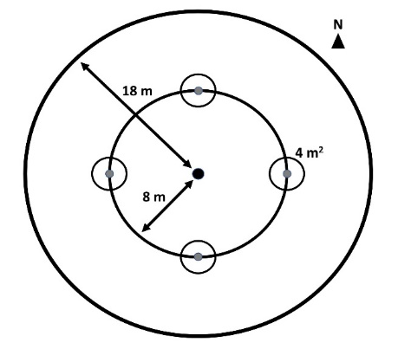

**b**

**Figure 1.** A) Map of southeast Michigan, showing the locations of the seven parks where forest stands were surveyed. B) Plot design, showing the 18 m radius main plot, the 8 m radius nested subplot, and the four 4 m2 area microplots located in cardinal directions.

Ash abundance and health

To assess the abundance and health of ash, canopy ash trees (≥10 cm diameter at breast height (DBH)) were surveyed within the 18 m radius main plots, understory ash trees (2.5-10 cm DBH) and living ash saplings (≥137 cm in height but <2.5 cm DBH) were surveyed within the central 8 m radius subplots, and ash seedlings (<137 cm in height) were surveyed within the 4 m2 microplots. All seedlings were checked for the presence of cotyledons which would indicate they were newly germinated (Klooster et al. 2014). Ash seedlings were counted in two height categories, <25 cm and >25 cm, and the percentage cover of ash seedlings in microplots was estimated (Klooster et al. 2014).

When present, overstory and understory ash (>2.5 cm DBH) were assessed individually for DBH, species, and health. All DBH measurements were taken at a height of 137 cm (Ward et al. 2021). Due to difficulties in distinguishing green and white ash, species designations were grouped into three categories: 1) black ash; 2) all other species of ash, including white ash, green ash, and potentially pumpkin ash (*Fraxinus profunda*); and 3) unknown ash species because the tree was dead. After recording ash species, the tree was checked for signs and symptoms of EAB, including the presence of D-shaped emergence holes, woodpecker predation marks, bark splitting, epicormic sprouts, and basal sprouts. Furthermore, the canopy condition was rated using a 1 to 5 scale, where 1 represented a healthy canopy, 5 represented complete defoliation of the canopy (possibly still with living epicormic sprouts), and 2-4 represented increasing stages of decline (Smith 2006, Klooster et al. 2014, Knight et al. 2014). For statistical analyses, we simplified the canopy condition variable into two binary variables, *ash tree decline* and *ash tree death*. *Ash tree decline* was coded as 1 if the canopy condition showed any signs of decline (i.e. if canopy condition ≥ 2) and 0 if the canopy condition = 1. *Ash tree death* was coded as 1 if canopy condition = 5, and 0 otherwise (adapted from Hoven et al. 2020).

EAB trapping

In 2024, we used purple-prism traps and multi-funnel traps to assess EAB presence at six of the seven study parks (Table S2). Two purple-prism traps were installed at each park, for a total of 12 prism traps. Additionally, three multi-funnel (Lindgren) traps were installed at one park, Pontiac Lake Recreation Area. Traps were hung on or near the biggest ash trees that could be found in preliminary site visits. Traps were installed between May 29 and June 5, 2024, and removed between July 23 and July 25, 2024. Purple prism traps used standard purple (“Coroplast purple”) colored board coated with Tangle Trap glue. Traps were hung at varying heights and near ash of varying size classes, depending on what was found at a park (Table S2). All traps were lured with Manuka oil and a fresh lure was installed halfway through the summer, between June 25 and July 3. All buprestid beetles were removed from purple prism traps monthly, and from multi-funnel traps weekly, and EAB was identified and sexed (Parsons 2008).

Parasitoid sampling

In 2024, yellow pan traps were used to determine whether EAB’s introduced biological control agents were present at one of the parks, Pontiac Lake Recreation Area. Plot 53 at Pontiac Lake (Transect: M, Hydroclass: mesic) was chosen because initial visits showed large numbers of regenerating ash. Some of the common plant species growing near the trunks of regenerating ash trees included spicebush (*Lindera benzoin*), bittersweet (*Celastrus orbiculatus*), Virginia creeper (*Parthenocissus quinquefolia*), and dogwood (*Cornus* sp.). A yellow pan trap was composed of two nested yellow plastic bowls attached to the trunk of a small ash tree and filled with a collection liquid (USDA–APHIS/ARS/FS 2021). The USDA design was modified by using polypropylene webbing straps instead of nails to attach to the tree (Figure S3). On June 4, 2024, 15 traps were attached at a height of 5-6 feet to small green or white ash trees with diameters between 3.2 and 9.6 cm DBH (Table S3). The collection liquid was 20% propylene glycol in water, with 1 drop of unscented dish soap. Traps were collected weekly until August 8, 2024, by pouring the collection liquid through a fine mesh paint filter (listed as 190 micron, actually ~300 micron = 0.3 mm), and rinsing with distilled water. As EAB’s introduced egg parasitoid *Oobius agrili* is 0.95 mm long (Zhang et al. 2005), a 0.3 mm mesh size should be sufficient to collect most *Oobius agrili* (although a smaller mesh would be ideal). Paint filters were cooled on ice within 30 minutes and frozen within 1 day (USDA–APHIS/ARS/FS 2021).

To sort trap contents, a paint filter was placed into a petri dish and 70% isopropanol in distilled water was added. All arthropods, except for thrips, springtails, mites, and small (< 1 mm) insect larvae, were counted and sorted into broad taxa. All Hymenoptera except Symphyta were sorted to superfamily level. Within the Ichneumonoidea, the families Ichneumonidae and Braconidae were distinguished. Within Chalcidoidea, the families Mymaridae and Encyrtidae were distinguished. Furthermore, the four introduced biological control agents of emerald ash borer were counted, which are *Tetrastichus planipennisi* (Chalcidoidea: Eulophidae: Tetrastichinae), *Spathius galinae* and *S. agrili* (Ichneumonoidea: Braconidae: Doryctinae) and *Oobius agrili* (Chalcidoidea: Encyrtidae). Parasitoids were identified using the USDA Guidelines (USDA–APHIS/ARS/FS 2021) before being confirmed by expert identification (Toby Petrice, personal communication).

Vegetation survey in hydric transects

In 2025, to investigate which species of trees are found in the hydric plots, overstory trees (here defined as ≥12.5 cm DBH) and understory trees (2.5-12.5 cm DBH) were counted in the 18 m radius main plot and the 8 m radius subplot, respectively. Only the 10 transects (30 plots) classified as hydric were surveyed. Trees were identified to species if possible and rated as living or dead (dead trees could still have living epicormic sprouts). Trees that divided into two or more branches below breast height (137 cm) were considered as the same tree and were counted if their sum of diameters was greater than the threshold (12.5 cm for the main plot or 2.5 cm for the subplot). Stems putatively connected below ground by root systems were considered as separate trees (Abella et al. 2019). The shrubs poison sumac (*Toxicodendron vernix*), autumn olive (*Eleagnus umbellata*), spicebush (*Lindera benzoin*), and winterberry (*Ilex verticillata*) were not recorded in the DBH survey but were instead quantified using a visual survey of percentage cover. Percentage cover was estimated for the aforementioned shrub species, as well as for glossy buckthorn (*Frangula alnus*), graminoids (grasses, cattails, and sedges), skunk cabbage (*Symplocarpus foetidus*), ferns, and standing water. Percentage cover was estimated for each of these categories by standing at 8 m in the NE, SE, SW, and NW quadrants of the 18 m radius plot. Each of the estimates was totaled for a plot-level estimate.

Statistical analysis

Counts of ash canopy and understory trees, non-ash canopy and understory trees, ash saplings, and ash seedlings were each summed across the three plots in a transect. Density was calculated by dividing the count by the area over which they were counted, and was reported in units of trees/ha, saplings/m2, or seedlings/m2. For canopy and understory trees, density of standing dead trees (canopy condition = 5) was calculated separately from density of living trees (canopy condition < 5). Basal area was calculated for living canopy and understory trees using the formula Σ(π*(d/2)2), where d is the DBH of each individual tree stem (Hoven et al. 2020). Multiple stems of a single tree were considered individually for basal area calculations but were considered as the same tree for tree density calculations. Basal area was reported in units of m2/hectare.

We used the existing categorization of transects (n=30) by hydrological class (xeric (18 transects), mesic (7 transects), and hydric (5 transects), Table S1) to test whether the abundance of ash differs based on soil moisture level. Our response variables were number of short ash seedlings (count), number of tall ash seedlings (count), mean percentage cover of ash seedlings (continuous), number of ash saplings (count), and number of living understory ash trees (count). We created separate models for each response variable. Hydrological class (xeric, mesic, or hydric) was treated as the fixed effect and Park where transect was located as random intercepts to account for unique site conditions at each of the seven parks. For each response variable which is count data, we first tried a Poisson generalized linear mixed-effects model (GLMM) with a log link function, implemented using the package ‘lme4’ in R (Bates et al. 2015). We used the package ‘DHARMa’ to determine if the observed data was adequately modelled by the GLMM (Hartig 2024). Whenever the Poisson GLMM was determined to be overdispersed, we created a new model using the negative binomial error structure. This was implemented using the ‘lme4’ and ‘MASS’ packages in R (Venables et al. 2002). We similarly observed the residuals of the negative binomial GLMM to verify model fit. We compared the Akaike Information Criterion (AIC) between the Poisson and negative binomial models to verify improvement in fit. The models for number of saplings and number of understory trees were a singular fit or did not converge, so we dropped the random effect of park for these response variables. The Anova function in the R package ’car‘ (Fox and Weisberg 2019) was used to test for differences in the response variables among hydrological classes, and Tukey contrasts were calculated using the R package ‘emmeans’ (Lenth 2024).

To assess differences in the percentage cover of ash seedlings among hydrological classes, the mean percentage cover of ash seedlings was calculated by averaging values across the 12 microplots in a transect (i.e., four microplots per plot * three plots). Due to issues with homoscedasticity of residuals, we transformed the response variable using the formula y’ = ln(y + 1), where y is the mean percentage cover. We developed a linear mixed-effects model using the R package ‘lme4’ (Bates et al. 2015) with the transformed mean percentage cover of ash seedlings as the response variable, hydrological class (xeric, mesic, or hydric) as the fixed effect predictor, and park as random intercepts. The Anova function in the R package ‘car’ (Fox and Weisberg 2019) was used to test for differences in the percentage cover of ash seedlings among hydrological classes, and Tukey contrasts were calculated using the R package ‘emmeans’ (Lenth 2024).

We hypothesized that ash tree diameter would be positively correlated with signs and symptoms of EAB attack. To test this hypothesis, we used generalized linear mixed-effects models with binomial error structure and a logit link function, implemented using the package ‘lme4’ (Bates et al. 2015). Each model included a binary response variable such as *presence of bark splitting*. The fixed effect predictor variable was always tree diameter at breast height (DBH). We included plot as a random intercept to account for non-independence of trees in a plot. We used a Z-test to test the null hypothesis that the slope coefficient was equal to zero. For our analysis, we pooled understory and overstory ash trees, then excluded any tree belonging to a plot where less than 10 trees were found, which gave us a sample size of 274 trees. We further removed two trees which had missing values, bringing our sample size to 272 trees. To assess the accuracy of the models, we created binned categories of tree diameter and calculated the proportion of trees in each bin that showed the sign or symptom. We observed whether our model line passed through the proportions for each bin, which would indicate a good model fit. To verify that our results did not depend on the data sub-setting criterion, we re-ran the models after only excluding trees belonging to plots where less than 5 trees were found. This adjusted criterion added 20 trees to the model, but did not change any of the results (Table S4).

**Results:**

In our survey of the 97 plots, we found ash (*Fraxinus*) in all but 5 plots. We found 2886 ash seedlings, 994 ash saplings, 264 living and 49 dead understory ash trees, and 7 living and 2 dead canopy ash trees. Of the ash seedlings, none had cotyledons, and thus no seedlings were newly germinated in 2024. However, in 2024 we did find isolated examples of ash seed production by four trees in the vicinity our study plots. These trees were located at Indian Springs Metropark and Proud Lake Recreation Area. Three out of four were black ash in hydric plots, and the diameter of the three seed-producing black ash trees ranged from 6.57 cm to 11.5 cm.

In our 2024 EAB trapping survey, the 12 prism traps caught a total of 18 EAB adults over the ~2 month trapping period. Most of the EAB individuals captured were from Kensington Metropark, but EAB was detected at all parks which were investigated except for Proud Lake, which caught zero EAB individuals (no traps were placed at Hudson Mills) (Figure S4). Although prism traps did not recover EAB at Proud Lake, EAB exit holes were found on ash trees at the park. The three multifunnel traps at Pontiac Lake caught a total of 6 EAB adults. Most (5 of 6) captures occurred between June 4 and June 21, 2024, and all captures were female.

Between June 4 and August 8, 2024, the yellow pan traps caught a total of 1537 Hymenoptera, 1074 Diptera, 1163 Hemiptera, 77 Lepidoptera, 277 Coleoptera, and 152 other arthropods. A total of three introduced biological control agents were detected, including *Spathius galinae* (3 individuals collected), *Oobius agrili* (2 individuals), and *Tetrastichus planipennisi* (2 individuals).

Ash seedlings (<137 cm in height):

Ash seedlings were found in stem densities ranging from 0 to 5.4 stems/m2, with an average of 2.0 stems/m2. Number of short ash seedlings varied by hydrological class (χ2=10.9, 2 df, p=0.004). Hydric transects had lower numbers of short seedlings than mesic (Z=-3.3, p=0.003) and xeric (Z=-2.6, p=0.027) transects, while differences between mesic and xeric transects were not statistically significant (Fig. 2A). Similarly, number of tall ash seedlings differed by hydrological class (χ2=12.7, p=0.002), with hydric transects having lower numbers than either mesic (Z=-3.5, p=0.001) or xeric (Z=-2.7, p=0.019) transects (Fig. 2A). Mean percentage cover of ash seedlings ranged from 0% to 38%, with an average of 12% across all transects. In mesic and xeric transects, the percentage cover of ash seedlings averaged 17% and 12%, respectively, but hydric transects had only 3% ash seedling cover on average. Statistics supported these trends, with percentage cover of ash seedlings varying by hydrological class (χ2=12.4, p=0.002), and hydric transects having significantly lower percent cover of ash seedlings than mesic (t=-3.2, p=0.010) and xeric transects (t=-3.0, p=0.018).

Ash saplings (≥137 cm in height and <2.5 cm DBH):

The density of ash saplings, across the 30 transects, ranged from 0 to 0.539 stems/m2 (0-5390 stems/hectare), with an average of 0.050 stems/m2 (500 stems/hectare). Any differences in number of saplings based on transect hydrological class were not significant (χ2=0.4, p=0.82) (Fig. 2B).

Ash small trees (2.5-10 cm DBH) and big trees (≥ 10 cm DBH):

A total of 187 understory ash trees were found in the 30 transects. Of these, 149 were living (canopy condition ≠ 5), while 38 were dead and at least partly standing. The density of living understory ash trees ranged from 0 to 1011 stems/hectare, with a mean of 82.3 stems/hectare. The number of living understory ash trees varied by hydrological class (χ2=8.38, p=0.015). Hydric transects had more understory ash trees than xeric transects (Z=2.5, p=0.033) (Fig. 2C).

NOTE WHICH SPECIES OF ASH WERE FOUND

Ash big trees (≥ 10 cm DBH):

Only 9 ash trees ≥ 10 cm DBH were found in the 30 transects, of which 7 were living. Living big trees within the plots ranged in diameter from 10.3 cm DBH to 12.4 cm DBH.

Ash basal area:

The basal area of living understory and canopy ash trees (all ash ≥ 2.5 cm DBH and canopy condition ≠ 5) ranged between 0 and 2.61 m2/hectare, with an average of 0.18 m2/hectare.

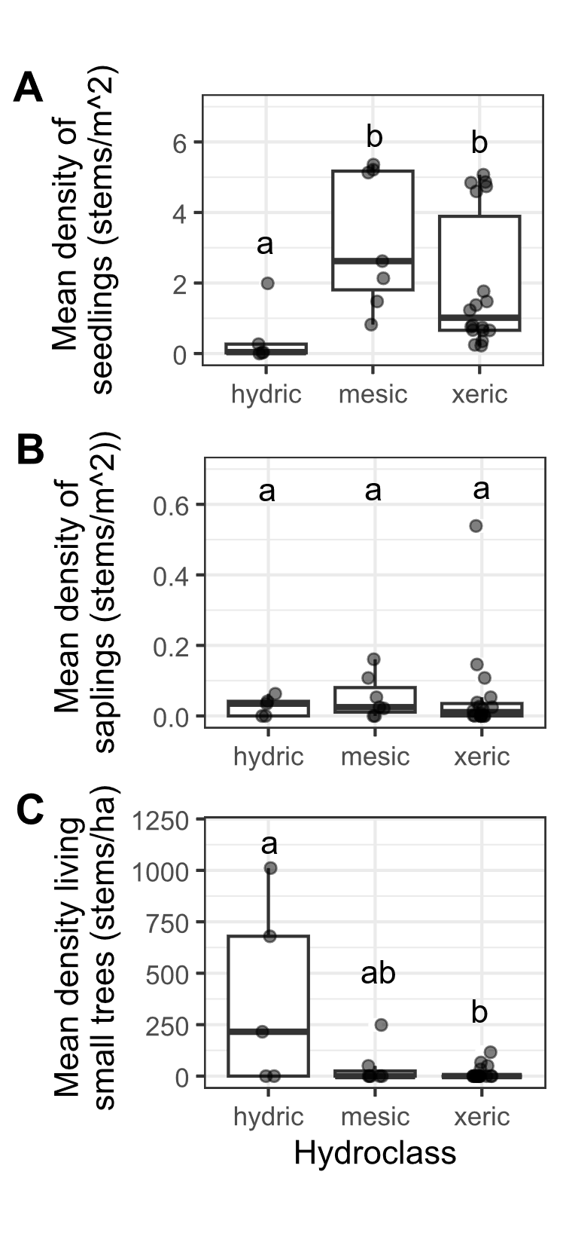

**Figure 2.** Ash occurrence in 30 transects in the Upper Huron River Watershed in southeast Michigan. The x-axis represents the soil hydroclass of the transect. Data points were overlayed on boxplots, with some horizontal jittering added. Lowercase letters above bars indicate statistically significant differences at α=0.05. A) Mean density of ash seedlings (all ash < 137 cm tall; short and tall seedling categories were combined for the graph), B) mean density of ash saplings (>= 137 cm tall and < 2.5 cm DBH), C) mean density of small ash trees (2.5 cm <= DBH < 10 cm).

Signs and symptoms of EAB

Signs or symptoms of EAB were found on 55 (5.5%) saplings. By far the most common symptom was bark splitting, which was found in 31 subplot quadrants out of 150 subplot quadrants with ash saplings. Other signs and symptoms of EAB were relatively rare or absent on ash saplings, including EAB exit holes (not found on saplings), woodpecker predation marks (found in 1 subplot quadrant), epicormic sprouts (found in 6 subplot quadrants), and basal sprouts (found in 3 subplot quadrants).

Signs and symptoms of EAB on ash trees

Of the symptoms of EAB, bark splitting was the most common and was found on 179 (56%) ash trees. Epicormic sprouts were found on 116 (36%) ash trees. Basal sprouts and woodpecker predation marks were found on 46 (14%) and 40 (12%) ash trees, respectively. Out of a total of 320 trees, 220 (69%) had canopy condition=1 (meaning they were healthy), 31 (10%) had canopy condition=2, 12 (4%) had canopy condition=3, 7 (2%) had canopy condition=4, and 50 (16%) had canopy condition=5 (meaning they had a dead canopy). The D-shaped emergence holes from EAB were observed on a low percentage of understory and canopy ash, with only 8 ash trees (2%) having exit holes (Fig. S1).

Relationship between ash tree diameter and EAB symptoms

The presence of woodpecker predation marks was positively correlated with tree diameter (DBH), with a 1 cm increase in DBH increasing the odds of woodpecker marks by 130% (Z=2.96, p=0.003) (Fig. 3A). Similarly, presence of epicormic sprouts was positively correlated with DBH, with a 1 cm increase in DBH increasing the odds of epicormic sprouts by 130% (Z=3.27, p=0.001) (Fig. 3C). The presence of canopy foliage decline was positively correlated with DBH, such that a 1 cm increase in DBH increased the odds of canopy decline by 126% (Z=3.26, p=0.001) (Fig. 3F). The relationship between DBH and bark splitting was not significant (Z=1.75, p=0.080) (Fig. 3B). The relationship between DBH and presence of basal sprouts was not significant (Z=1.75, p=0.080) (Fig. 3D). Additionally, the relationship between DBH and the tree having a canopy condition of 5 (meaning it is dead) was not significant (Z=0.73, p=0.465) (Fig. 3E).

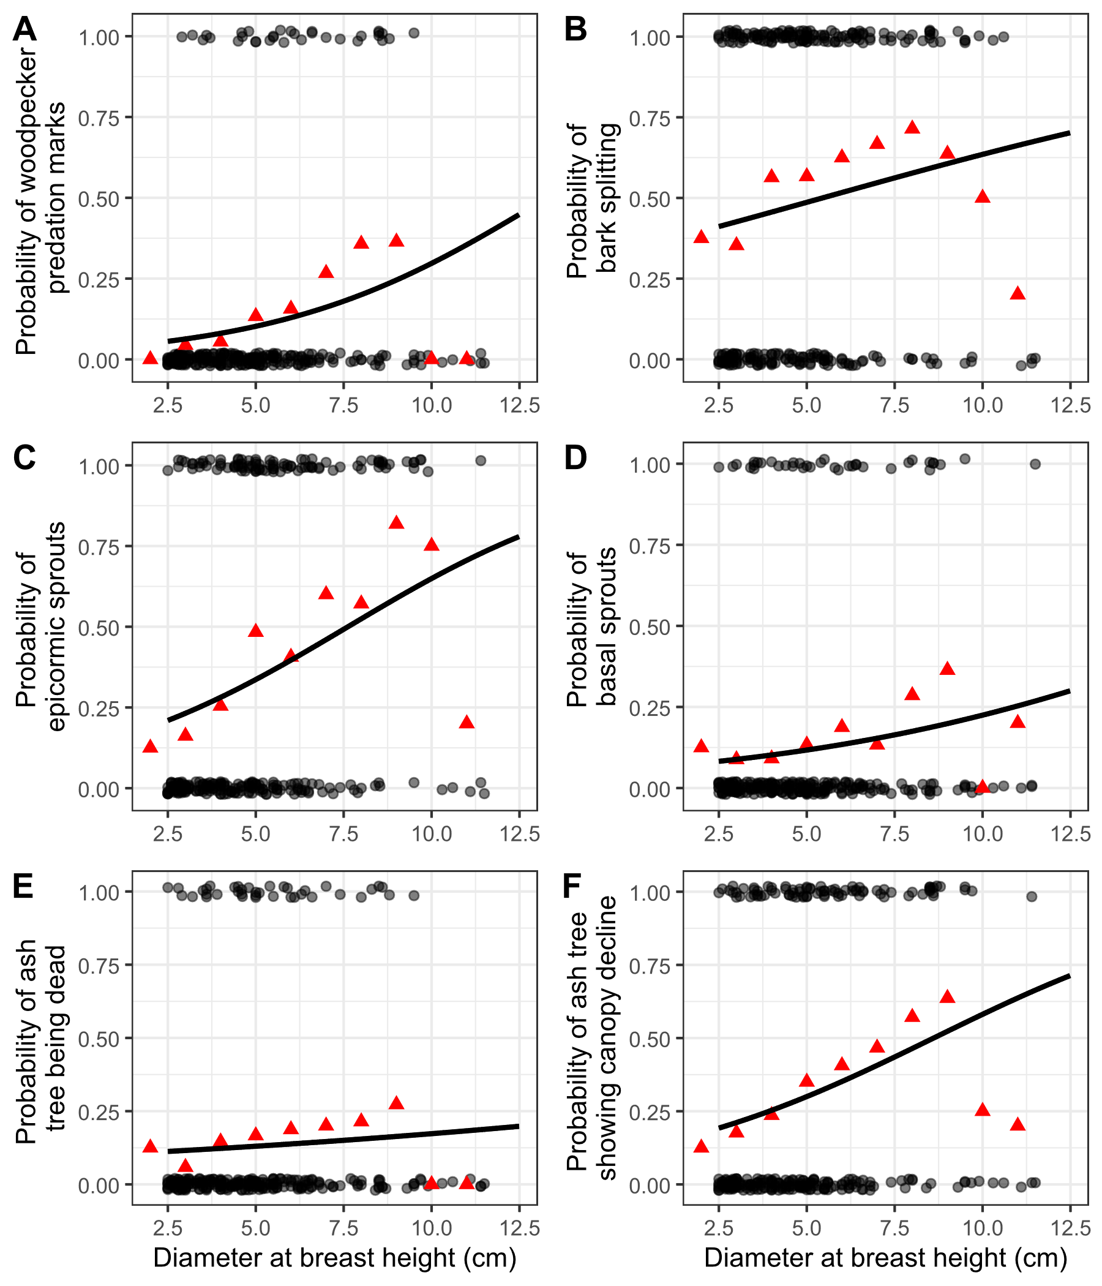

**Figure 3.** The presence or absence of symptoms of EAB plotted against tree diameter at breast height (DBH) for 272 trees in 9 forest plots. Grey circles are individual trees, which are plotted as y=1 for presence or y=0 for absence (points were jittered slightly up and down). Black line shows the overall fitted model, disregarding each specific random intercept for each plot. Red triangles show the proportion of trees within a DBH bin that have the symptom. For E, tree death is defined as having a canopy condition of 5. For F, canopy decline is defined as having a canopy condition between 2-5 (minor to complete defoliation).

Vegetation responses in hydric stands

How many canopy and understory trees were found in total? What was the average density of trees? How about the average basal area? What were the most abundant species?

What were the most abundant types of understory cover?

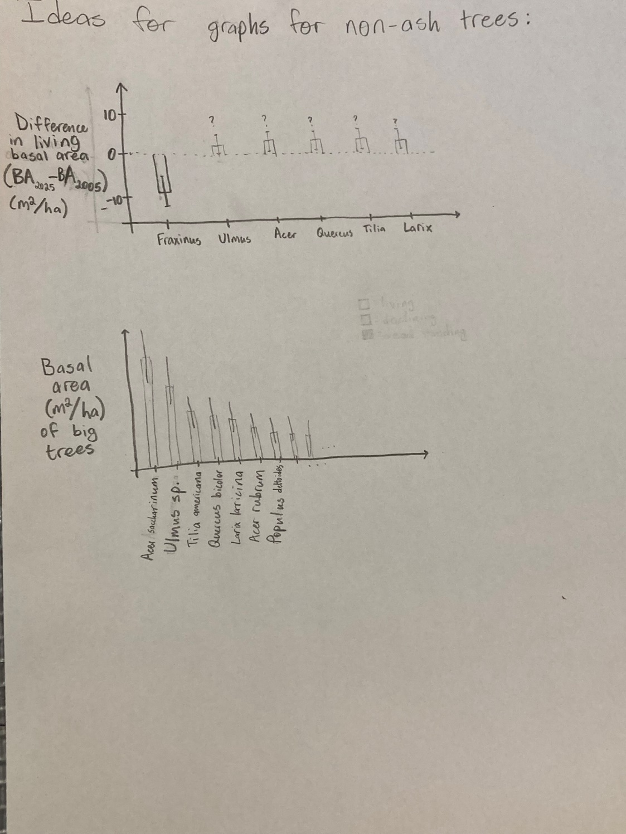

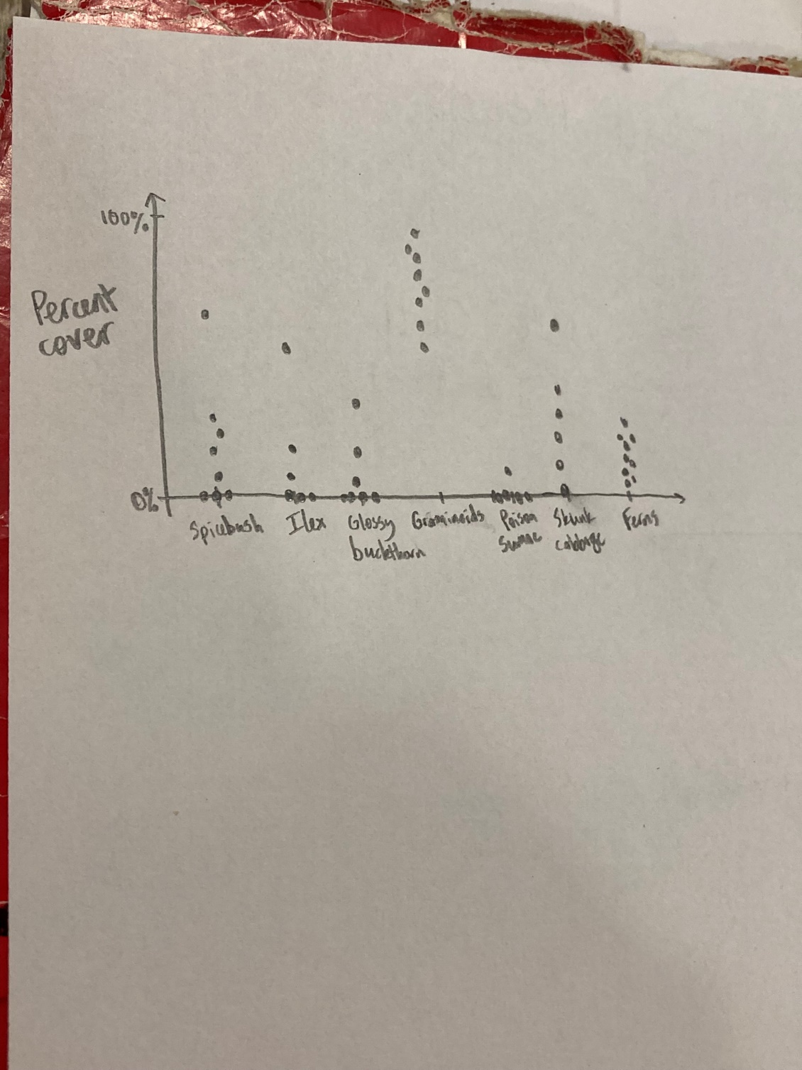

**Discussion**

In the discussion, I need to mention what are the key takeaways from the research. Here are some ideas:

-The ash seedling layer is still abundant in mesic and xeric forests, but not in hydric forests.

-Compare this result to other studies.

-Seed germination of ash seedlings has almost entirely ceased.

-Compare to Klooster and Kashian

-Small green and black ash trees are abundant in some hydric forests, but not all.

-Compare to Siegert, Engelken, Abella, etc.

-Occurrence of epicormic sprouts, woodpecker predation marks, and defoliation all increase with increasing tree diameter from 2.5 cm to 10 cm.

-A result about what genera of trees, if any, have increased in basal area in hydric transects. And whether these genera are adapted to flooding stress, and whether they have any other threats (such as Dutch elm disease)

-A note about the ground cover of hydric sites, and what kinds of wildlife can be supported by shrub wetlands, sedge meadows, and spicebush-dominated areas.

-I think it’s important to note other potential factors that might be controlling the response of hydric forests to EAB. For one, the pH of the ground. Some hydric forests might have higher pH, hard water from groundwater flow. Other forests might have lower pH water from rainfall. White ash prefers soils with higher levels of Ca2+ and Mg2+ ions, and it is conceivable that the other species of ash could also be affected by pH (Royo and Knight 2012). Additionally, the forests on river floodplains might differ from those in swampy areas farther from rivers, because flowing water can have higher dissolved oxygen than standing water, and rivers can be a source of nutrients.

A paragraph about compensatory growth:

Because ash previously composed a large portion of total tree biomass in multiple forest types (Wagner and Todd 2015), the death of most overstory ash trees led to a reduction in living tree biomass. It is uncertain which trees, shrubs, or herbaceous plants will replace the space previously occupied by ash trees. In one scenario, the surrounding non-ash canopy trees increase their growth rate after the death of canopy ash, in a process called compensatory growth. Compensatory growth was observed in forests of Ohio between 2012 and 2014, where plots with higher amounts of declining ash trees had higher growth rates of non-ash trees (Hoven et al. 2020). A similar pattern was found using tree cores of red and silver maples (*Acer rubrum* and *Acer saccharinum*) in northeast Ohio (Costilow et al. 2017). However, another study which simulated EAB invasion in swamp forests of Upper Michigan found that the growth rates of non-ash overstory trees did not respond to the girdling or cutting of ash trees, at least for the first three growing seasons. Rather, herbaceous plants, including sedges (*Carex* sp.) and obligate wetland species, increased in the plots where canopy ash were killed (Davis et al. 2017). Similarly, in forests near Toledo, OH, basal area of non-ash trees has only partially compensated for the loss due to ash mortality, 14 years after EAB invasion (Abella et al. 2019).

A note about symptoms of EAB:

When examining the proportions of trees showing symptoms for groups binned by DBH, we noticed that the 9.5-10.5 cm group and the 10.5-11.5 cm group had lower-than-expected proportions of trees showing symptoms of EAB attack (Fig. 2, red triangles). Thus, the binomial GLMMs are not perfectly modelling the observed patterns. However, it must be noted that many of the ash in the 9.5-11.5 cm DBH range were from only one plot, plot 72 at Indian Springs.

**Supplementary Information**

We tested whether the arthropod community differed between ash trees showing canopy decline (indicating possible EAB infection) vs. ash trees with a full canopy. To do this, we categorized the 15 ash trees as either healthy (Canopy condition = 1, 9 trees) or declining (Canopy condition > 1, 6 trees). We used ash tree health (healthy vs. declining) as the predictor variable. Our response variables were the total number individuals of each taxonomic group caught between June 27 and August 1 (these intervals were fully sorted into taxonomic groups). Specifically, we tested any groups for which >= 15 individuals were caught in total, including total number of arthropods, Symphyta (sawflies), Dryinidae (pincer wasps), Formicidae (ants), Pompilloidea (spider wasps), Apoidea (bees and sphecoid wasps), Ichneumonidae, Braconidae, Diapriidae (shelf-faced wasps), Ceraphronoidea, Mymaridae (fairy wasps), Encyrtidae, Platygastroidea, Diptera (flies), Hemiptera (true bugs), Lepidoptera (moths), and Coleoptera (beetles). We ran a Mann-Whitney U-test for each response variable.

**Supplementary Tables**

**Table S1.** Plot locations for the 111 plots visited in this study. Each set of three plots makes up a transect. Each transect was given a hydrological class of xeric, mesic, or hydric.

|  |  |  |  |  |  |  |
| --- | --- | --- | --- | --- | --- | --- |
| **Plot**  **number** | **Plot name** | **Park** | **Transect** | **Latitude** | **Longitude** | **Hydrological**  **class** |
| 1 | KENUPHD | Kensington | A | 42.53254195 | -83.6705388 | xeric |
| 2 | KENUPHD2 | Kensington | A | 42.53296724 | -83.67076505 | xeric |
| 3 | KENUPHD3 | Kensington | A | 42.53326356 | -83.67093244 | xeric |
| 4 | HMHD | Hudson Mills | AA | 42.37834666 | -83.91336117 | mesic |
| 5 | HMHD2 | Hudson Mills | AA | 42.3779638 | -83.91309216 | mesic |
| 6 | HMHD3 | Hudson Mills | AA | 42.37830402 | -83.91382332 | mesic |
| 7 | KENDRY | Kensington | B | 42.53544514 | -83.66722319 | xeric |
| 8 | KENDRY2 | Kensington | B | 42.53563361 | -83.66642756 | xeric |
| 9 | KENDRY3 | Kensington | B | 42.53588209 | -83.66709668 | xeric |
| 10 | HMDRY | Hudson Mills | BB | 42.37515735 | -83.91411337 | xeric |
| 11 | HMDRY2 | Hudson Mills | BB | 42.37474575 | -83.91429938 | xeric |
| 12 | HMDRY3 | Hudson Mills | BB | 42.37398156 | -83.91421887 | xeric |
| 13 | KENUP | Kensington | C | 42.53463699 | -83.66695495 | xeric |
| 14 | KENUP2 | Kensington | C | 42.53497995 | -83.66657034 | xeric |
| 15 | KENUP3 | Kensington | C | 42.53429542 | -83.66721965 | xeric |
| 16 | ILOPEN | Island Lake | CC | 42.49941418 | -83.7165664 | mesic |
| 17 | ILOPEN2 | Island Lake | CC | 42.50011316 | -83.71690408 | mesic |
| 18 | ILOPEN3 | Island Lake | CC | 42.49984426 | -83.71729405 | mesic |
| 19 | KENDRY3 | Kensington | D | 42.53784433 | -83.66665362 | xeric |
| 20 | KENDRY3A | Kensington | D | 42.53794168 | -83.66596685 | xeric |
| 21 | KENDRY3B | Kensington | D | 42.53727952 | -83.66639485 | xeric |
| 22 | ILLOW | Island Lake | DD | 42.49971912 | -83.71630958 | hydric |
| 23 | ILLOW2 | Island Lake | DD | 42.50085549 | -83.7166848 | hydric |
| 24 | ILLOW3 | Island Lake | DD | 42.49794685 | -83.71775494 | hydric |
| 25 | PLINT | Proud Lake | E | 42.5759159 | -83.52099242 | xeric |
| 26 | PLINT2 | Proud Lake | E | 42.57601569 | -83.52054316 | xeric |
| 27 | PLINT3 | Proud Lake | E | 42.57637225 | -83.52026922 | xeric |
| 28 | HLMAT | Highland | EE | 42.64473456 | -83.56669535 | xeric |
| 29 | HLMAT2 | Highland | EE | 42.64590976 | -83.56680506 | xeric |
| 30 | HLMAT3 | Highland | EE | 42.64686284 | -83.56915982 | xeric |
| 31 | PLDRYMAT | Proud Lake | F | 42.57578816 | -83.52318352 | xeric |
| 32 | PLDRYMAT2 | Proud Lake | F | 42.57577574 | -83.52399007 | xeric |
| 33 | PLDRYMAT2A | Proud Lake | F | 42.57635459 | -83.52182426 | xeric |
| 34 | PLCONF | Proud Lake | G | 42.57571524 | -83.52814029 | xeric |
| 35 | PLDRYMAT3 | Proud Lake | G | 42.57581763 | -83.52740826 | xeric |
| 36 | PLDRYMAT3A | Proud Lake | G | 42.57607392 | -83.52668128 | xeric |
| 37 | PLWET | Proud Lake | H | 42.5747667 | -83.54598723 | hydric |
| 38 | PLWET2 | Proud Lake | H | 42.57474279 | -83.54632682 | hydric |
| 39 | PLWET3 | Proud Lake | H | 42.57428658 | -83.54708265 | hydric |
| 40 | KENWET | Kensington | I | 42.53043348 | -83.67041583 | hydric |
| 41 | KENWET2 | Kensington | I | 42.53110591 | -83.66746124 | hydric |
| 42 | KENWET4 | Kensington | I | 42.53118814 | -83.66648081 | hydric |
| 43 | KENWET3 | Kensington | J | 42.53124676 | -83.66897599 | hydric |
| 44 | KENWET3A | Kensington | J | 42.53101609 | -83.66944111 | hydric |
| 45 | KENWET3B | Kensington | J | 42.53146534 | -83.6685188 | hydric |
| 49 | PONUP | Pontiac Lake | L | 42.67601991 | -83.48374379 | xeric |
| 50 | PONUP2 | Pontiac Lake | L | 42.67639534 | -83.48336561 | xeric |
| 51 | PONUP3 | Pontiac Lake | L | 42.67695181 | -83.48354417 | xeric |
| 52 | PONHD | Pontiac Lake | M | 42.67737591 | -83.4842027 | mesic |
| 53 | PONHD2 | Pontiac Lake | M | 42.67763539 | -83.48494077 | mesic |
| 54 | PONHD3 | Pontiac Lake | M | 42.67619344 | -83.48458083 | mesic |
| 55 | PONEAST | Pontiac Lake | N | 42.67628637 | -83.48161802 | xeric |
| 56 | PONEAST2 | Pontiac Lake | N | 42.67644003 | -83.48223133 | xeric |
| 57 | PONEAST3 | Pontiac Lake | N | 42.67655527 | -83.4827693 | xeric |
| 58 | PONRT | Pontiac Lake | O | 42.67697644 | -83.48225793 | xeric |
| 59 | PONRT2 | Pontiac Lake | O | 42.67847161 | -83.4821571 | xeric |
| 60 | PONRT3 | Pontiac Lake | O | 42.67796779 | -83.48337831 | xeric |
| 61 | ILRIP | Island Lake | P | 42.50511387 | -83.711563 | hydric |
| 62 | ILRIP2 | Island Lake | P | 42.50548015 | -83.71130397 | hydric |
| 63 | ILRIP3 | Island Lake | P | 42.50506543 | -83.71105671 | hydric |
| 64 | ILCC | Island Lake | Q | 42.49871458 | -83.71880034 | hydric |
| 65 | ILCC2 | Island Lake | Q | 42.49826164 | -83.71911588 | hydric |
| 66 | ILCC3 | Island Lake | Q | 42.49755544 | -83.7194028 | hydric |
| 67 | ISMATDRY | Indian Springs | R | 42.70259786 | -83.49652337 | mesic |
| 68 | ISMATDRY2 | Indian Springs | R | 42.70213825 | -83.49648848 | mesic |
| 69 | ISMATDRY3 | Indian Springs | R | 42.70223513 | -83.49584728 | mesic |
| 70 | ISLD | Indian Springs | S | 42.7016922 | -83.49741597 | hydric |
| 71 | ISLD2 | Indian Springs | S | 42.70129243 | -83.49740698 | hydric |
| 72 | ISLD3 | Indian Springs | S | 42.70142849 | -83.49779967 | hydric |
| 73 | ISMATDE | Indian Springs | T | 42.7035437 | -83.49463936 | xeric |
| 74 | ISMATDE2 | Indian Springs | T | 42.70375308 | -83.49415138 | xeric |
| 75 | ISMATDE3 | Indian Springs | T | 42.70278921 | -83.49360562 | xeric |
| 76 | ISRIP | Indian Springs | U | 42.70463303 | -83.49570897 | hydric |
| 77 | ISRIP2 | Indian Springs | U | 42.70481219 | -83.494821 | hydric |
| 78 | ISRIP3 | Indian Springs | U | 42.70487822 | -83.4940807 | hydric |
| 79 | ISOPEN | Indian Springs | V | 42.70480262 | -83.49706373 | mesic |
| 80 | ISOPEN2 | Indian Springs | V | 42.70388702 | -83.49893342 | mesic |
| 81 | ISOPEN3 | Indian Springs | V | 42.7045196 | -83.49803841 | mesic |
| 82 | HLMATFR | Highland | W | 42.6489291 | -83.55636056 | xeric |
| 83 | HLMATFR2 | Highland | W | 42.64858561 | -83.55689617 | xeric |
| 84 | HLMATFR3 | Highland | W | 42.64939898 | -83.55761483 | xeric |
| 85 | HLRIP | Highland | X | 42.64587606 | -83.55093888 | mesic |
| 86 | HLRIP2 | Highland | X | 42.64514371 | -83.55089568 | mesic |
| 87 | HLRIP3 | Highland | X | 42.64637211 | -83.55062169 | mesic |
| 88 | HLUP | Highland | Y | 42.6470476 | -83.55230573 | xeric |
| 89 | HLUP2 | Highland | Y | 42.64705538 | -83.55397741 | xeric |
| 90 | HLUP3 | Highland | Y | 42.6474566 | -83.55365762 | xeric |
| 91 | HMMAT | Hudson Mills | Z | 42.37824499 | -83.91166168 | xeric |
| 92 | HMMAT2 | Hudson Mills | Z | 42.37825474 | -83.91229145 | xeric |
| 93 | HMMAT3 | Hudson Mills | Z | 42.3787298 | -83.91267589 | xeric |
| 94 | PONNEW | Pontiac Lake | ZA | 42.67554541 | -83.48274071 | xeric |
| 95 | PONNEW2 | Pontiac Lake | ZA | 42.67584028 | -83.4830424 | xeric |
| 96 | PONNEW3 | Pontiac Lake | ZA | 42.67606664 | -83.48271281 | xeric |
| 97 | PONRD | Pontiac Lake | ZB | 42.67546355 | -83.4821069 | mesic |
| 98 | PONRD2 | Pontiac Lake | ZB | 42.67597751 | -83.48183457 | mesic |
| 99 | PONRD3 | Pontiac Lake | ZB | 42.67611495 | -83.4822095 | mesic |
| 100 | PONWH | Pontiac Lake | ZC | 42.67657235 | -83.48190157 | xeric |
| 101 | PONWH2 | Pontiac Lake | ZC | 42.67696268 | -83.48095924 | xeric |
| 102 | PONWH3 | Pontiac Lake | ZC | 42.67670871 | -83.48046038 | xeric |
| 103 | ISBR | Indian Springs | ZD | 42.70640403 | -83.49342124 | hydric |
| 104 | ISBR2 | Indian Springs | ZD | 42.70623663 | -83.4938222 | hydric |
| 105 | ISBR3 | Indian Springs | ZD | 42.70670773 | -83.49360969 | hydric |
| 106 | ISBRS | Indian Springs | ZE | 42.70572744 | -83.49386673 | hydric |
| 107 | ISBRS2 | Indian Springs | ZE | 42.70535737 | -83.49412394 | hydric |
| 108 | ISBRS3 | Indian Springs | ZE | 42.70514295 | -83.49498565 | hydric |
| 109 | ISWH | Indian Springs | ZF | 42.70282112 | -83.49624363 | mesic |
| 110 | ISWH2 | Indian Springs | ZF | 42.70256049 | -83.49579452 | mesic |
| 111 | ISWH3 | Indian Springs | ZF | 42.70249606 | -83.49513887 | mesic |
| 112 | KENNEW | Kensington | ZG | 42.53359794 | -83.67122473 | xeric |
| 113 | KENNEW2 | Kensington | ZG | 42.53386003 | -83.67146597 | xeric |
| 114 | KENNEW3 | Kensington | ZG | 42.5343776 | -83.6712658 | xeric |

**Table S2.** Trap locations for the 2024 purple-prism and multi-funnel traps installed to assess EAB presence.



**Table S3.** Yellow pan trap information for 2024 parasitoid sampling effort. All traps were within ~30 meters of the center tree for Plot 53 at Pontiac Lake Recreation Area.

|  |  |  |  |  |  |  |  |  |
| --- | --- | --- | --- | --- | --- | --- | --- | --- |
| **Trap number** | **DBH of ash (cm)** | **Canopy condition**  **(1-5)** | **EAB exit holes?** | **Woodpecker marks?** | **Ash bark splitting?** | **Epicormic sprouts?** | **Basal sprouts?** | **Canopy condition (binary)** |
| 101 | 3.2 | 3 | n | n | y | y | y | Declining |
| 102 | 5.2 | 1 | n | n | y | n | n | Healthy |
| 103 | 6.6 | 1 | n | n | y | y | n | Healthy |
| 104 | 7.2 | 1 | n | n | y | y | n | Healthy |
| 105 | 3.1 | 3 | y | n | y | y | y | Declining |
| 106 | 5.9 | 1 | n | n | y | n | n | Healthy |
| 107 | 3.6 | 1 | n | n | n | y | n | Healthy |
| 108 | 4.45 | 1 | n | n | y | n | n | Healthy |
| 109 | 7.2 | 1 | n | n | y | y | n | Healthy |
| 110 | 8.9 | 1 | n | n | n | n | n | Healthy |
| 111 | 4.6 | 4 | n | n | y | y | y | Declining |
| 112 | 6.7 | 3 | n | n | y | y | n | Declining |
| 113 | 9.6 | 2 | n | n | n | n | n | Declining |
| 114 | 4.2 | 1 | n | n | y | y | n | Healthy |
| 115 | 9.1 | 4 | n | y | y | y | y | Declining |

**Table S4.** Statistical results for the model of the relationship between ash tree diameter and symptoms of EAB. The slope coefficient is the fitted coefficient which is multiplied by tree diameter within the model. The 10-tree criterion is where ash trees were only included if they belonged to plots where 10 or more ash trees were found. The p-value is the probability, under the assumption that the true slope is zero, that we would find a slope coefficient larger in absolute value than the observed slope coefficient. Rows are bolded if the p-value was found to be less than 0.05.

|  |  |  |  |  |  |  |
| --- | --- | --- | --- | --- | --- | --- |
| EAB Symptom | Slope coefficient for 10 tree criterion | Slope coefficient for  5 tree criterion | Z value for 10 tree criterion | Z value for 5 tree criterion | p value for 10 tree criterion | p value for 5 tree criterion |
| **Woodpecker marks** | **0.26223** | **0.22817** | **2.956** | **2.721** | **0.00312** | **0.0065** |
| Bark splitting | 0.12159 | 0.10369 | 1.752 | 1.474 | 0.0798 | 0.140 |
| **Epicormic sprouts** | **0.25899** | **0.24421** | **3.273** | **3.179** | **0.00106** | **0.001479** |
| Basal sprouts | 0.1564 | 0.13092 | 1.751 | 1.568 | 0.08 | 0.117 |
| Ash tree death | 0.06692 | 0.04342 | 0.731 | 0.506 | 0.465 | 0.613 |
| **Ash tree decline** | **0.23492** | **0.18551** | **3.259** | **2.689** | **0.00112** | **0.00717** |

**Supplementary figures**

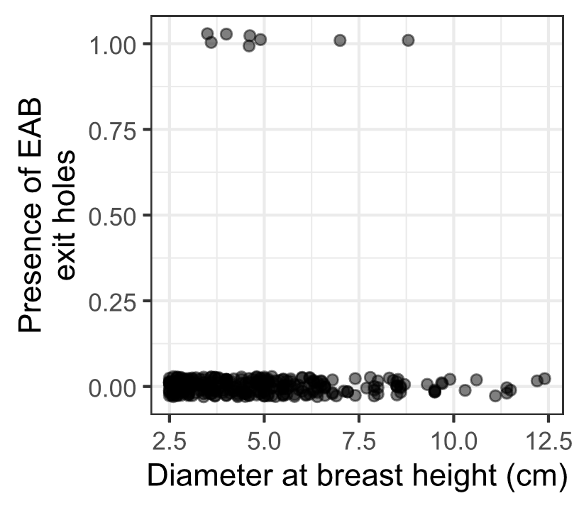

**Figure S1.** The presence or absence of visible EAB exit holes on the trunk at around eye level. Only 8 of 321 ash trees had EAB exit holes that were spotted. Points are jittered to improve visibility.

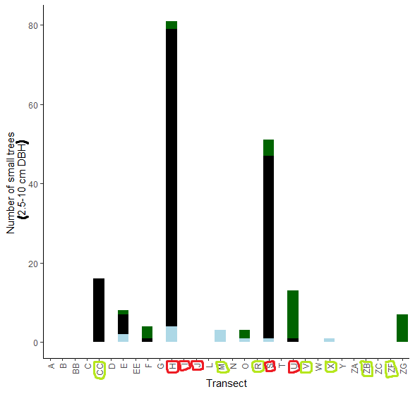

**Figure S2.** The total number of small ash trees (2.5 – 10 cm DBH) found in 30 completed transects in the Upper Huron River Watershed. Small ash of all canopy conditions are counted. Hydric transects are circled in red, while mesic transects are circled in light green. Bars are shaded based on the proportion of each ash species that was found in a transect. Dark green represents green, white, and/or pumpkin ash; black represents black ash; light blue represents unknown species.

**Figure S3.** Yellow pan trap design using nested yellow bowls attached to a wooden stand and strapped to an ash tree.

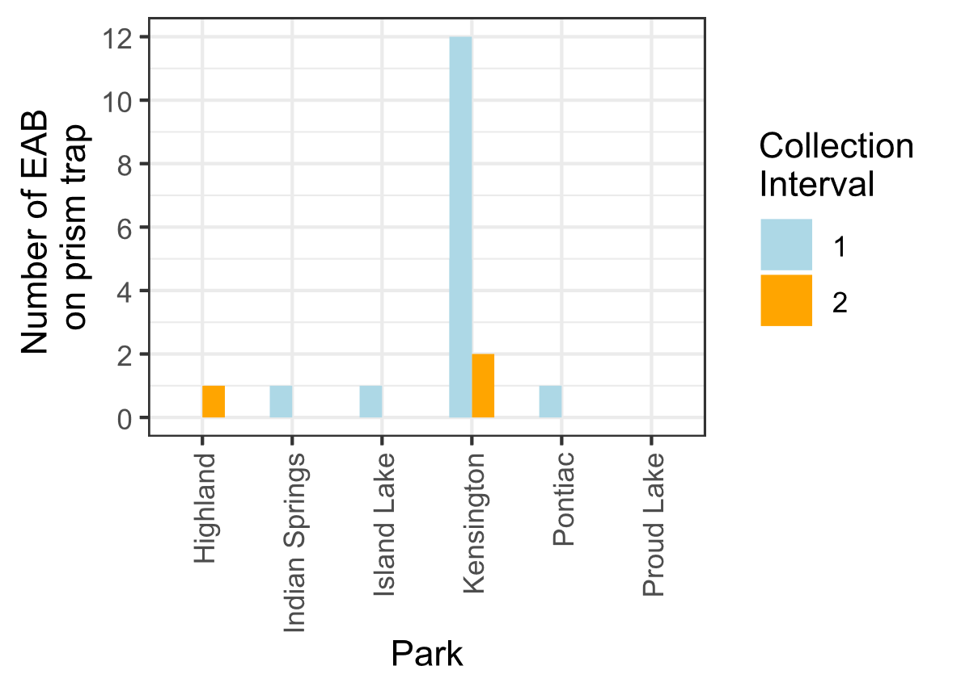

**Figure S4.** Captures of EAB adults from Prism traps in 2024. Collection interval 1 corresponds to June, while collection interval 2 corresponds to July.

**References:**

Abell, K. J., J. J. Duan, L. Bauer, J. P. Lelito, and R. G. Van Driesche. 2012. The effect of bark thickness on host partitioning between Tetrastichus planipennisi (Hymen: Eulophidae) and Atanycolus spp. (Hymen: Braconidae), two parasitoids of emerald ash borer (Coleop: Buprestidae). Biological Control 63:320–325.

Abella, S. R., C. E. Hausman, J. F. Jaeger, K. S. Menard, T. A. Schetter, and O. J. Rocha. 2019. Fourteen years of swamp forest change from the onset, during, and after invasion of emerald ash borer. Biological Invasions 21:3685–3696.

Abella, S. R., K. S. Menard, T. A. Schetter, and C. E. Hausman. 2024. Species and landscape variation in tree regeneration and 17 years of change in forested wetlands invaded by emerald ash borer. Forest Ecology and Management 557:121750.

Aker, S. A., R. B. De Andrade, J. J. Duan, and D. S. Gruner. 2022. Rapid Spread of an Introduced Parasitoid for Biological Control of Emerald Ash Borer (Coleoptera: Buprestidae) in Maryland. Journal of Economic Entomology 115:381–386.

Aubin, I., F. Cardou, K. Ryall, D. Kreutzweiser, and T. Scarr. 2015. Ash regeneration capacity after emerald ash borer (EAB) outbreaks: Some early results. The Forestry Chronicle 91:291–298.

Barnes, B. V. 1976. Succession in deciduous swamp communities of southeastern Michigan formerly dominated by American elm. Canadian Journal of Botany 54:19–24.

Bates, D., M. Mächler, B. Bolker, and S. Walker. 2015. Fitting Linear Mixed-Effects Models Using **lme4**. Journal of Statistical Software 67.

Burns, R., and B. Honkala. 1990. Silvics of North America: Volume 2, Hardwoods.

Costilow, K. C., K. S. Knight, and C. E. Flower. 2017. Disturbance severity and canopy position control the radial growth response of maple trees (Acer spp.) in forests of northwest Ohio impacted by emerald ash borer (Agrilus planipennis). Annals of Forest Science 74:10.

Davis, J. C., J. P. Shannon, N. W. Bolton, R. K. Kolka, and T. G. Pypker. 2017. Vegetation responses to simulated emerald ash borer infestation in *Fraxinus nigra* dominated wetlands of Upper Michigan, USA. Canadian Journal of Forest Research 47:319–330.

Duan, J. J., L. S. Bauer, K. J. Abell, M. D. Ulyshen, and R. G. Van Driesche. 2015. Population dynamics of an invasive forest insect and associated natural enemies in the aftermath of invasion: implications for biological control. Journal of Applied Ecology 52:1246–1254.

Duan, J. J., L. S. Bauer, and R. G. Van Driesche. 2017. Emerald ash borer biocontrol in ash saplings: The potential for early stage recovery of North American ash trees. Forest Ecology and Management 394:64–72.

Duan, J. J., J. R. Gould, N. F. Quinn, T. R. Petrice, B. H. Slager, T. M. Poland, L. S. Bauer, C. E. Rutledge, J. S. Elkinton, and R. G. Van Driesche. 2023. Protection of North American ash against emerald ash borer with biological control: ecological premises and progress toward success. BioControl 68:87–100.

Engelken, P. J., M. E. Benbow, and D. G. McCullough. 2020. Legacy effects of emerald ash borer on riparian forest vegetation and structure. Forest Ecology and Management 457:117684.

Fox, J., and S. Weisberg. 2019. An {R} Companion to Applied Regression. Sage, Thousand Oaks {CA}.

Gandhi, K. J. K., and D. A. Herms. 2010. Direct and indirect effects of alien insect herbivores on ecological processes and interactions in forests of eastern North America. Biological Invasions 12:389–405.

Hartig, F. 2024. DHARMa: Residual Diagnostics for Hierarchical (Multi-Level / Mixed) Regression Models. R.

Hoven, B. M., K. S. Knight, V. E. Peters, and D. L. Gorchov. 2020. Release and suppression: forest layer responses to emerald ash borer (Agrilus planipennis)-caused ash death. Annals of Forest Science 77:10.

Klooster, W., K. Gandhi, L. Long, K. Perry, K. Rice, and D. Herms. 2018. Ecological Impacts of Emerald Ash Borer in Forests at the Epicenter of the Invasion in North America. Forests 9:250.

Klooster, W. S. 2012. Forest Responses to Emerald Ash Borer-Induced Ash Mortality. PhD Thesis, The Ohio State University.

Klooster, W. S., D. A. Herms, K. S. Knight, C. P. Herms, D. G. McCullough, A. Smith, K. J. K. Gandhi, and J. Cardina. 2014. Ash (Fraxinus spp.) mortality, regeneration, and seed bank dynamics in mixed hardwood forests following invasion by emerald ash borer (Agrilus planipennis). Biological Invasions 16:859–873.

Knight, K. S., B. P. Flash, R. H. Kappler, J. A. Throckmorton, B. Grafton, and C. E. Flower. 2014. Monitoring Ash (Fraxinus spp.) Decline and Emerald Ash Borer (Agrilus planipennis) Symptoms in Infested Areas. General Technical Report, U.S. Department of Agriculture, Forest Service, Northern Research Station.

Kolka, R., A. D’Amato, J. Wagenbrenner, R. Slesak, T. Pypker, M. Youngquist, A. Grinde, and B. Palik. 2018. Review of Ecosystem Level Impacts of Emerald Ash Borer on Black Ash Wetlands: What Does the Future Hold? Forests 9:179.

Lenth, R. V. 2024. emmeans: Estimated Marginal Means, aka Least-Squares Means. R.

Lovett, G. M., C. D. Canham, M. A. Arthur, K. C. Weathers, and R. D. Fitzhugh. 2006. Forest Ecosystem Responses to Exotic Pests and Pathogens in Eastern North America. BioScience 56:395.

McCormick, J. F., and R. B. Platt. 1980. Recovery of an Appalachian Forest Following the Chestnut Blight or Catherine Keever-You Were Right! American Midland Naturalist 104:264.

McCullough, D. G. 2019. Challenges, tactics and integrated management of emerald ash borer in North America. Forestry: An International Journal of Forest Research 93:197–211.

Mech, A. M., K. A. Thomas, T. D. Marsico, D. A. Herms, C. R. Allen, M. P. Ayres, K. J. K. Gandhi, J. Gurevitch, N. P. Havill, R. A. Hufbauer, A. M. Liebhold, K. F. Raffa, A. N. Schulz, D. R. Uden, and P. C. Tobin. 2019. Evolutionary history predicts high‐impact invasions by herbivorous insects. Ecology and Evolution 9:12216–12230.

Megonigal, J. P., W. H. Conner, S. Kroeger, and R. R. Sharitz. 1997. ABOVEGROUND PRODUCTION IN SOUTHEASTERN FLOODPLAIN FORESTS: A TEST OF THE SUBSIDY–STRESS HYPOTHESIS. Ecology 78:370–384.

Morris, T. D., J. R. Gould, J. Drake, and M. K. Fierke. 2023. Status of ash forests and regeneration a decade after first detection of emerald ash borer infestation in New York state. Forest Ecology and Management 549:121464.

Murphy, T. C., R. G. Van Driesche, J. R. Gould, and J. S. Elkinton. 2017. Can Spathius galinae attack emerald ash borer larvae feeding in large ash trees? Biological Control 114:8–13.

Niinemets, Ü., and F. Valladares. 2006. TOLERANCE TO SHADE, DROUGHT, AND WATERLOGGING OF TEMPERATE NORTHERN HEMISPHERE TREES AND SHRUBS. Ecological Monographs 76:521–547.

Palik, B. J., M. E. Ostry, R. C. Venette, and E. Abdela. 2012. Tree regeneration in black ash (Fraxinus nigra) stands exhibiting crown dieback in Minnesota. Forest Ecology and Management 269:26–30.

Parsons, G. 2008. Emerald Ash Borer: A guide to identification and comparison to similar species. Michigan State University Department of Entomology.

Perry, K., and D. Herms. 2019. Dynamic Responses of Ground-Dwelling Invertebrate Communities to Disturbance in Forest Ecosystems. Insects 10:61.

Quinn, N. F., T. R. Petrice, J. M. Schmude, T. M. Poland, L. S. Bauer, C. E. Rutlege, R. G. Van Driesche, J. S. Elkinton, and J. J. Duan. 2023. Postrelease assessment of *Oobius agrili* (Hymenoptera: Encyrtidae) establishment and persistence in Michigan and the Northeastern United States. Journal of Economic Entomology 116:1165–1170.

Roy, H. E., L.-J. Lawson Handley, K. Schönrogge, R. L. Poland, and B. V. Purse. 2011. Can the enemy release hypothesis explain the success of invasive alien predators and parasitoids? BioControl 56:451–468.

Royo, A. A., and K. S. Knight. 2012. White ash (Fraxinus americana) decline and mortality: The role of site nutrition and stress history. Forest Ecology and Management 286:8–15.

Siegert, N. W., P. J. Engelken, and D. G. McCullough. 2021. Changes in demography and carrying capacity of green ash and black ash ten years after emerald ash borer invasion of two ash-dominant forests. Forest Ecology and Management 494:119335.

Smith, A. 2006. Effects of Community Structure on Forest susceptibility and Response to the Emerald Ash Borer Invasion of the Huron River Watershed in Southeast Michigan. Master’s Thesis, The Ohio State University.

Smith, A., D. A. Herms, R. P. Long, and K. J. K. Gandhi. 2015. Community composition and structure had no effect on forest susceptibility to invasion by the emerald ash borer (Coleoptera: Buprestidae). The Canadian Entomologist 147:318–328.

Telander, A. C., R. A. Slesak, A. W. D’Amato, B. J. Palik, K. N. Brooks, and C. F. Lenhart. 2015. Sap flow of black ash in wetland forests of northern Minnesota, USA: Hydrologic implications of tree mortality due to emerald ash borer. Agricultural and Forest Meteorology 206:4–11.

USDA–APHIS/ARS/FS. 2021. Emerald Ash Borer Biological Control Release and Recovery Guidelines. USDA–APHIS–ARS–FS, Riverdale, Maryland.

Van Driesche, R., and R. Reardon. 2016. The Use of Classical Biological Control to Preserve Forests in North America. USDA Forest Service, Morgantown, WV.

Venables, W. N., B. D. Ripley, and W. N. Venables. 2002. Modern applied statistics with S. 4th ed. Springer, New York.

Villari, C., D. A. Herms, J. G. A. Whitehill, D. Cipollini, and P. Bonello. 2016. Progress and gaps in understanding mechanisms of ash tree resistance to emerald ash borer, a model for wood‐boring insects that kill angiosperms. New Phytologist 209:63–79.

Wagner, D. L., and K. J. Todd. 2015. Chapter 2: Ecological Impacts of Emerald Ash Borer. Page Biology and Control of Emerald Ash Borer. USDA Forest Service.

Ward, S. F., A. M. Liebhold, R. S. Morin, and S. Fei. 2021. Population dynamics of ash across the eastern USA following invasion by emerald ash borer. Forest Ecology and Management 479:1–8.

Zhang, Y.-Z., D.-W. Huang, T.-H. Zho, H.-P. Liu, and L. S. Bauer. 2005. Two new species of egg parasitoids (hymenoptera: Encyrtidae) of wood-boring beetle pests from China. Phytoparasitica 33:253–260.